**FIRST INDIAN HARLEY CLUB WORKSHOP.**

On Tuesday 19th March 2024 a small group of members gathered at 211 Garvey Road, Crooked Brook for the inaugural Indian Harley Club Mechanical Workshop. The concept of the workshop was for members to meet in a practical environment where they could talk about the mechanics of all types of motorcycles. It was hoped that those with a vast knowledge and operational workshop skills could assist those with limited knowledge and skills. The passing of knowledge and skill is invaluable as we age.

I opened up my sheds to members and offered them the use of what ever I had that could assist them to demonstrate a skill or carry out a repair on a motorcycle. It started at 9am with coffee and biscuits, a little early for a beer, and general greetings and small talk. After a tour of the sheds we had a 1929, Model M4, AJS turn up on a trailer. I am embarrassed as I forget the name for the members who owns it. My apologies but I have to move on.

We off loaded it from the trailer on the belief that the magneto was faulty. The bike would start but under acceleration cut out. The precious piece was placed onto the operating table and the examination began. The experts gathered and discussed an appropriate methodology to examine the patient.

Once agreed upon a spark tester was attached whilst Doctor Turner held the led. The bike was kicked over and we had spark everywhere. The magneto was ruled out and we moved to the stopcock. The hose was disconnected and about 5 mls per hour was coming out. The balance line was disconnected with nothing coming out although the left side tank was half full.

A closer inspection found that lines contained enough substance to fill a litre bottle. The tank came off and all lines and tap placed into the ultrasonic cleaner. Half an hour later we had parts equal to brand new. The bike was put back together and just needed a few new washers before the big test.

The bike went home with the owner untested. We can only hope we solved the issue.

By 12 most had enough coffee and biscuits and the first work shop closed.

I only hope that Workshop concept will work. From my short time in the club I have found the knowledge and support offered by everyone is invaluable. A couple of years ago I heard that Dick Taylor was selling his Velocette Venom and a Velocette club member in Victoria was interested in it. I knew that Dick was hoping his bike would stay in WA so I spoke with him and ended up buying it. I had no knowledge of the  Velocette mechanically or otherwise but was willing to learn.

Dick’s Velocette was known as the Exxon Valdez due to it continually leaking oil. I decided to clean it up and commenced in stripping it down. I actually found that I had indeed purchased a Velocette motorcycle and not a frame wrapped in oil. I found the main cause of the oil seeping was the threaded oil inlet to the oil pump. To fix this the entire engine has to be removed from the bike. This also meant the gear box had to be separated and the clutch removed.

Once done I had a quick lesson on Velocette clutches and primary cover straps. After speaking with many Velocette owners who gladly provided helpful hints and advice I had the bike back together after my son, Ryan, sorted out the threading issue.

Once back together I just couldn’t get it started. Tried everything I knew, very little but nothing helped. However after discussing the issue with Muzza, Huw and Steve I took their advice and cleaned the magneto pick-up, new to me, and checked the valve - lifter gaps. Once done, hit the starter and there you go, immediate action. Fired up straight away.

I have mentioned this because I am sure that there are many members like myself who are keen to learn but due to our limited knowledge find it difficult and struggle with manuals. Hands on practical examples are worth their weight in gold.

So I invite all to come and say hello on the work shop day and pass on your knowledge.

Below are some photographs of the inaugural Workshop.

Regards George Loverock



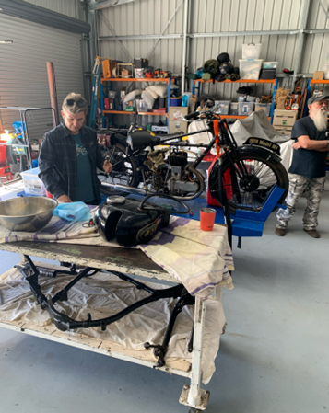

**Above Patient mid operation, Right Dr Turner with the patient, prior to the operation**