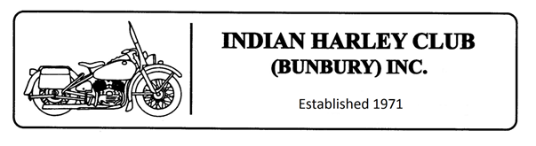Expense Reimbursement Claim

Member Name: _______________________ Member Number: __________
Bank Name: _______________________
BSB: _ _ _ - _ _ _ A/C: ____________________

Rally Date | Rally Name as per approved Club Calendar | Total
……./ ….…./ ……….... | …………………………………………………………………………..  Route Setter / Backup Driver (circle) | *1*  ≤$75 (pre approved)
Purchase Date | Item Description & Purpose | Total
……./ ….…./ ……….... |  | *2*
……./ ….…./ ……….... |  | *2*
……./ ….…./ ……….... |  | *2*
……./ ….…./ ……….... |  | *2*
……./ ….…./ ……….... |  | *2*
*1* Receipts not required for Route Setter or Backup Driver Claims
*2* Please attach receipts for all other claims to this form

Claimant Signature: ___________________ Date Submitted: ……./ ……../ …………..

…………………………………………………..Committee Use Only …...……………………………………………………

Approved: YES / NO Name/Pos’n: _____________________ Sign: _____________

Paid: ……. / …….. / …………… Method: EFT / Other ……………………… Entered in Xero

